

Instituto Politécnico Nacional
Escuela Superior de Computo

Materia: Fundamentos de Diseño Digital
Profesor: Iván Diaz Toalá
Equipo:
Oswaldo Gil Valentín
Rojas Tapia Italuu
Godínez Pérez Karla
Grupo: 3CV4 Fecha: 10/12/2023
Actividad: Reporte Practica 5



Descripción:
Un convertidor BCD a 7 segmentos es un circuito lógico que toma un número en formato BCD (Binary-Coded Decimal) y lo convierte en una señal adecuada para mostrarlo en un display de 7 segmentos. El formato BCD representa cada dígito decimal con su equivalente binario de 4 bits.
Cálculos de diseño:
 | Entradas |  |  |  | Salidas
N | A | B | C | D | Caso 1 | Caso 2
0 | 0 | 0 | 0 | 0 | 0 | 0
1 | 0 | 0 | 0 | 1 | 0 | 0
2 | 0 | 0 | 1 | 0 | 1 | 1
3 | 0 | 0 | 1 | 1 | 1 | 1
4 | 0 | 1 | 0 | 0 | 0 | 0
5 | 0 | 1 | 0 | 1 | 1 | 1
6 | 0 | 1 | 1 | 0 | 0 | 0
7 | 0 | 1 | 1 | 1 | 1 | 1
8 | 1 | 0 | 0 | 0 | 0 | 0
9 | 1 | 0 | 0 | 1 | 0 | 0
10 | 1 | 0 | 1 | 0 | X | X
11 | 1 | 0 | 1 | 1 | X | X
12 | 1 | 1 | 0 | 0 | X | X
13 | 1 | 1 | 0 | 1 | X | X
14 | 1 | 1 | 1 | 0 | X | X
15 | 1 | 1 | 1 | 1 | X | X

a(A,B,C,D)=∑(0,2,3,5-9) + β(10-15)
b(A,B,C,D)=∑(0-4,7-9) + β(10-15)
c(A,B,C,D)=∑(0,1,3-9) + β(10-15)
d(A,B,C,D)=∑(0,2,3,5,6,8) + β(10-15)
e(A,B,C,D)=∑(0,2,6,8) + β(10-15)
f(A,B,C,D)=∑(0,4-6,8,9) + β(10-15)
g(A,B,C,D)=∑(2-6,8,9) + β(10-15)

a(A,B,C,D)=∑(0,2,3,5-9) + β(10-15) b(A,B,C,D)=∑(0-4,7-9) + β(10-15)
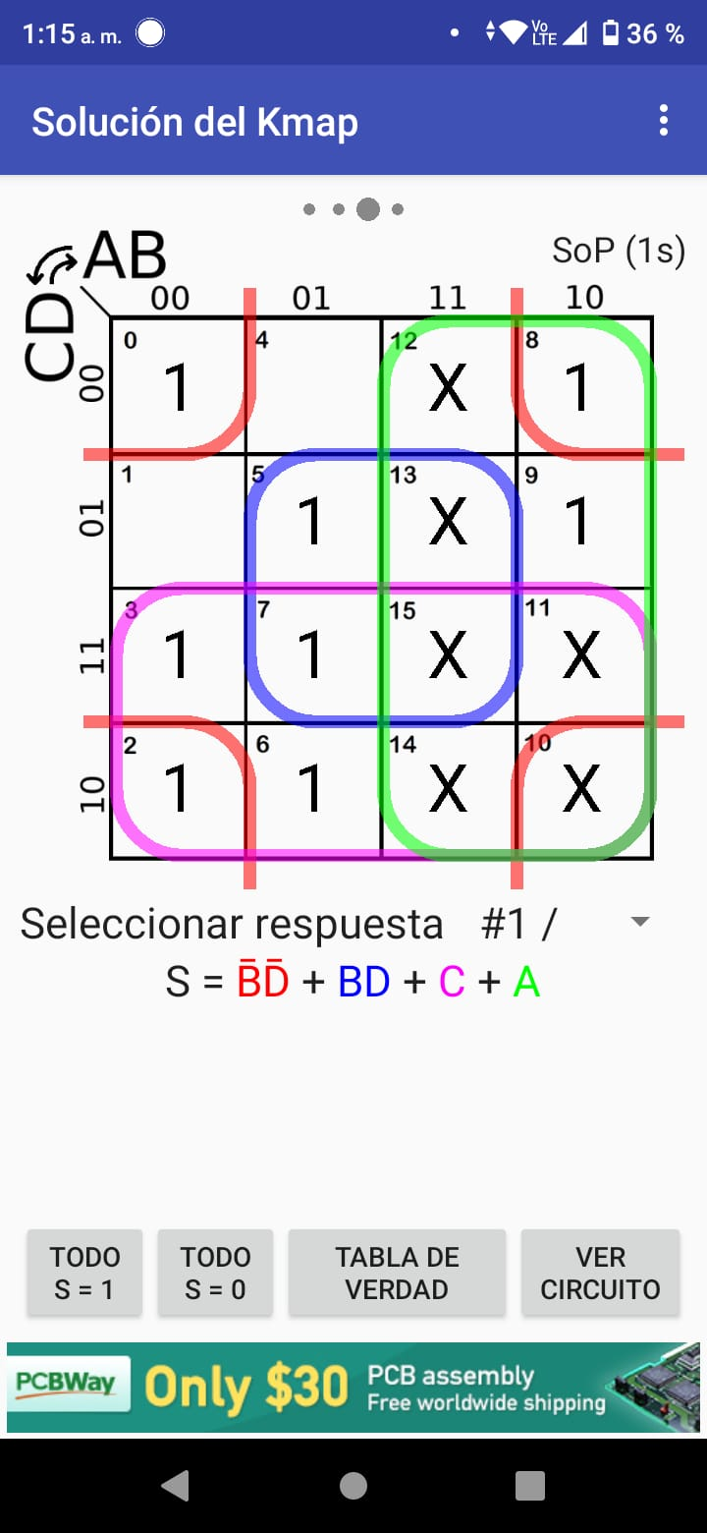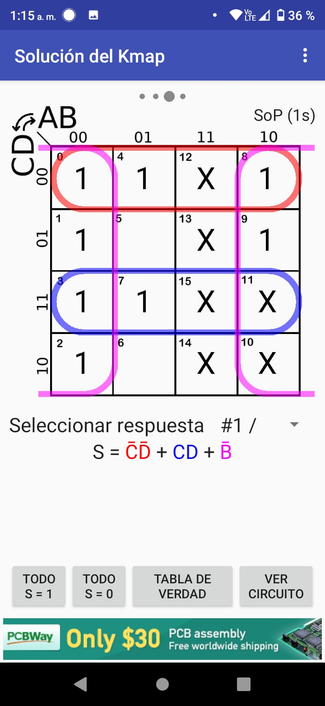
c(A,B,C,D)=∑(0,1,3-9) + β(10-15) d(A,B,C,D)=∑(0,2,3,5,6,8) + β(10-15)
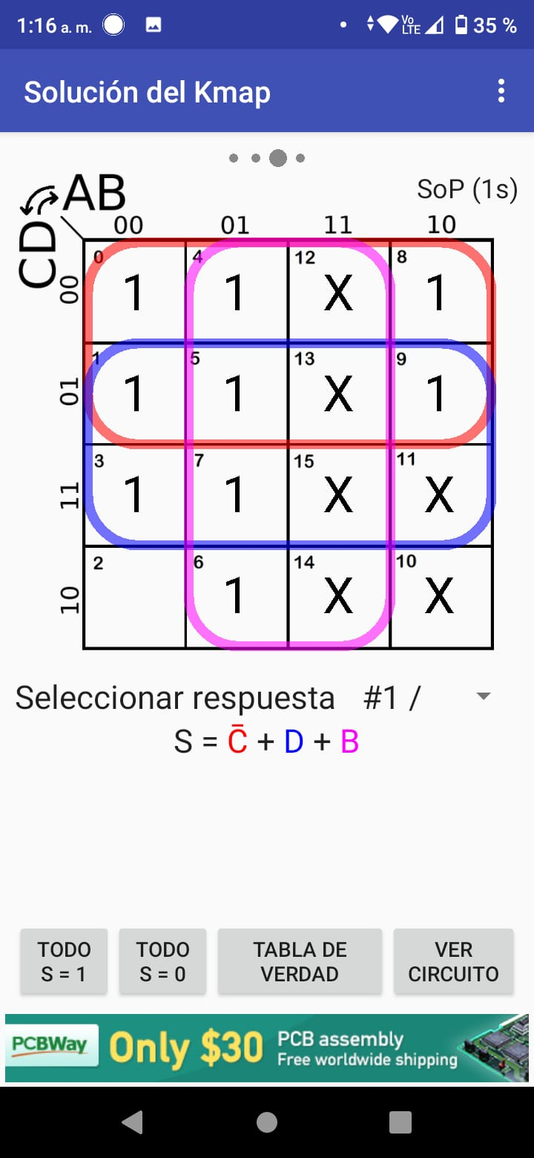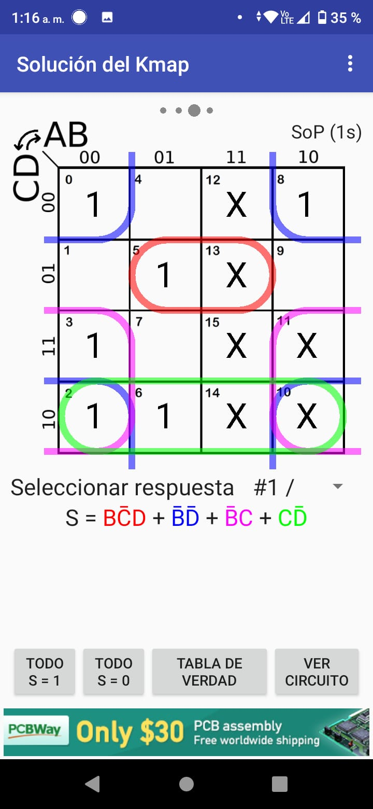

e(A,B,C,D)=∑(0,2,6,8) + β(10-15) f(A,B,C,D)=∑(0,4-6,8,9) + β(10-15)
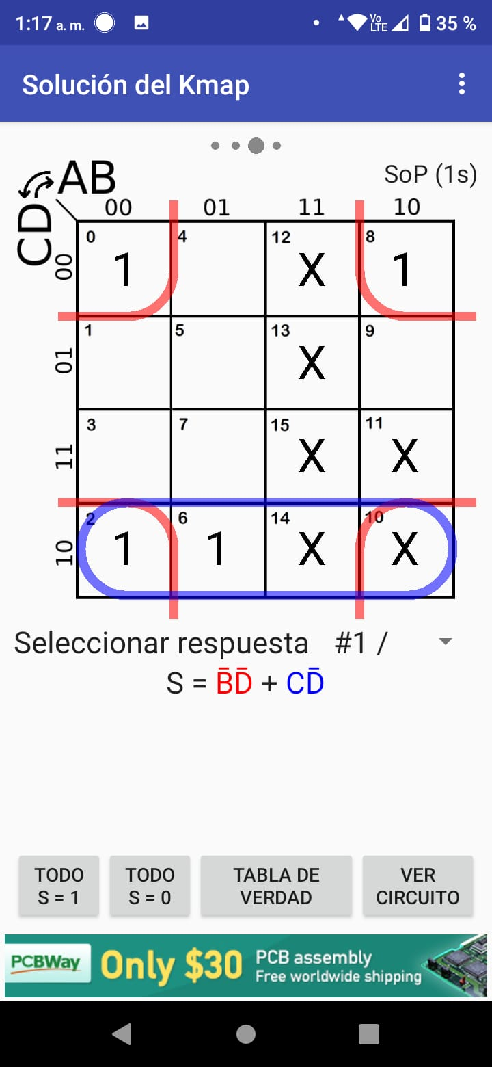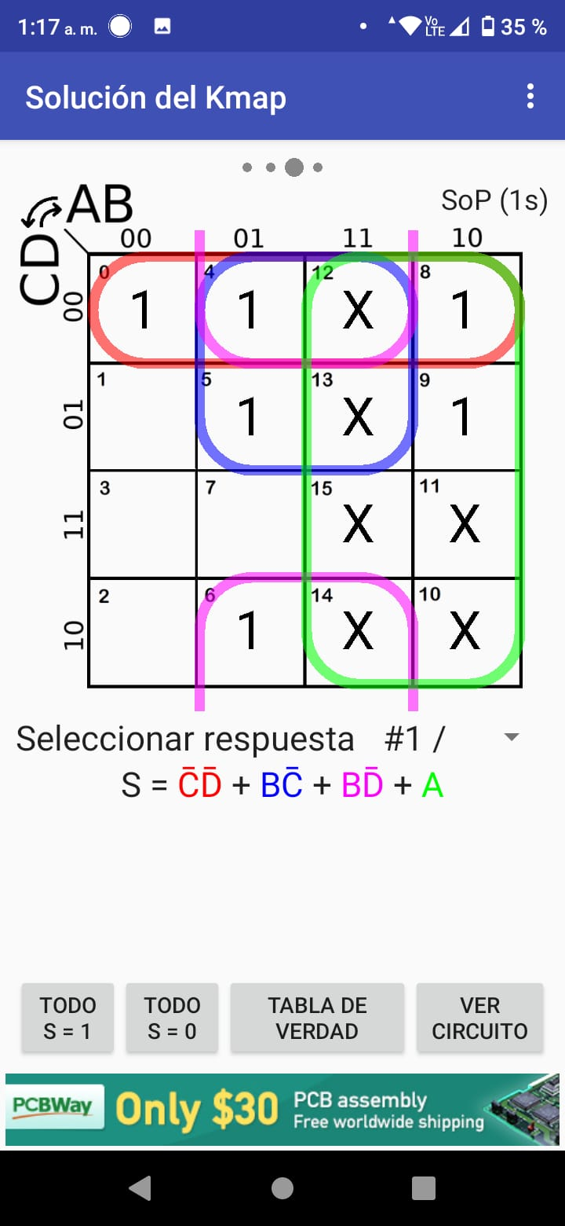
g(A,B,C,D)=∑(2-6,8,9) + β(10-15)
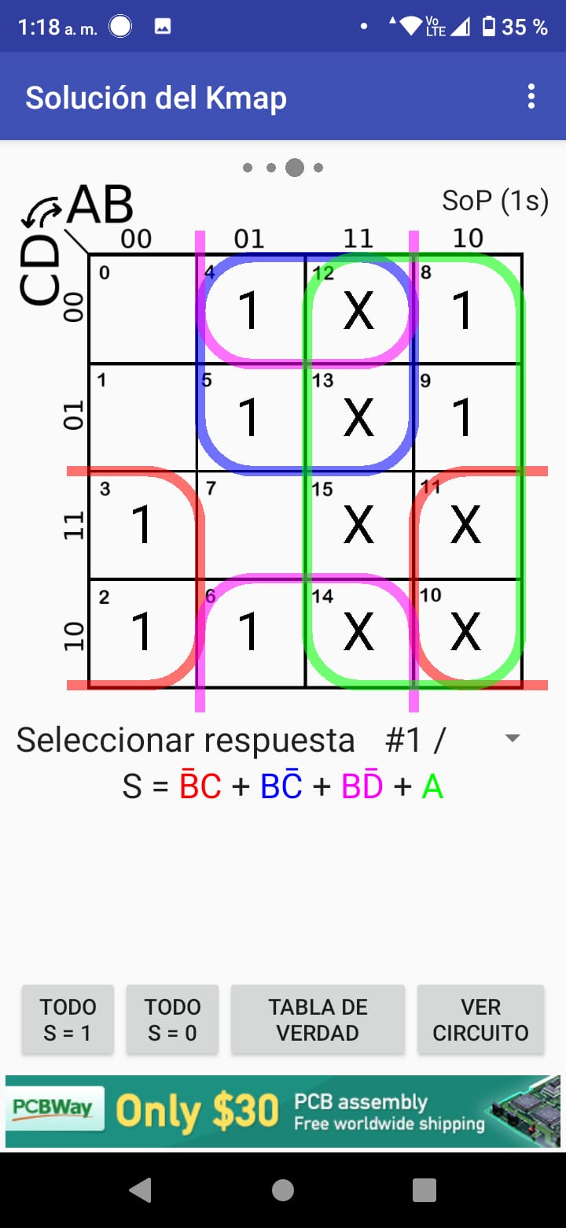

Código VHDL:
library ieee;
use ieee.std_logic_1164.all;

entity BCD7SEG is port(A, B, C, D: in std_logic;
F1: out std_logic;
F2: out std_logic;
F3: out std_logic;
F4: out std_logic;
F5: out std_logic;
F6: out std_logic;
F7: out std_logic);
end BCD7SEG;

architecture BCD7SEG of BCD7SEG is begin

F1 <=((NOT B) AND (NOT D)) OR (B AND D) OR (C) OR (A);
F2 <=((NOT C) AND (NOT D)) OR (C AND D) OR (NOT B);
F3 <=(NOT C) OR (D) OR (B);
F4 <=((NOT B) AND (NOT D)) OR ((NOT B) AND C) OR (C AND (NOT D)) OR (B AND (NOT C) AND D);
F5 <=((NOT B) AND (NOT D)) OR (C AND (NOT D));
F6 <=(A) OR (B AND (NOT C)) OR (B AND (NOT D)) OR ((NOT C) AND (NOT D));
F7 <=(A) OR (B AND (NOT C)) OR ((NOT B) AND C) OR (C AND (NOT D));

end BCD7SEG;

Evidencias de prueba del circuito (fotografías de circuito y su funcionamiento):
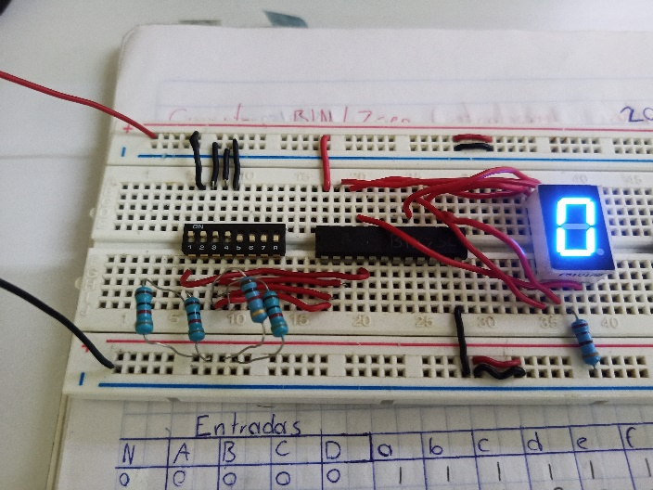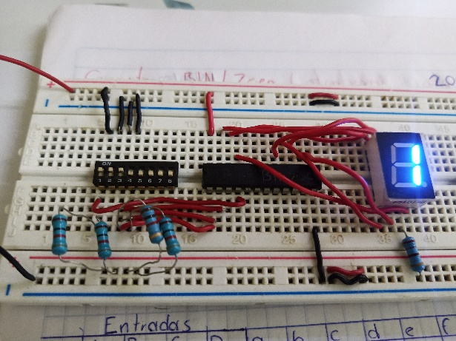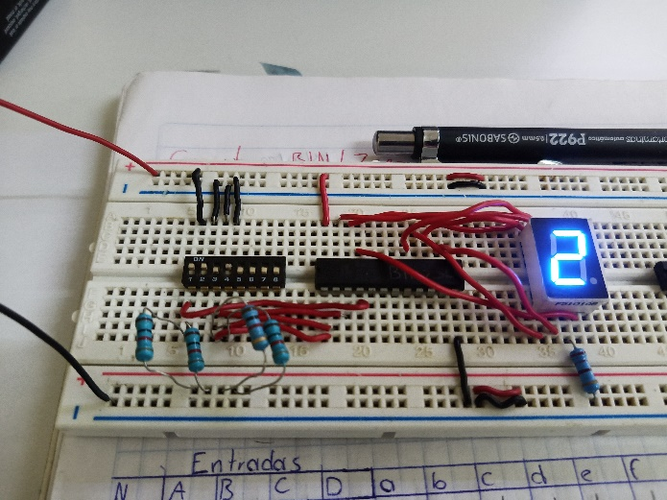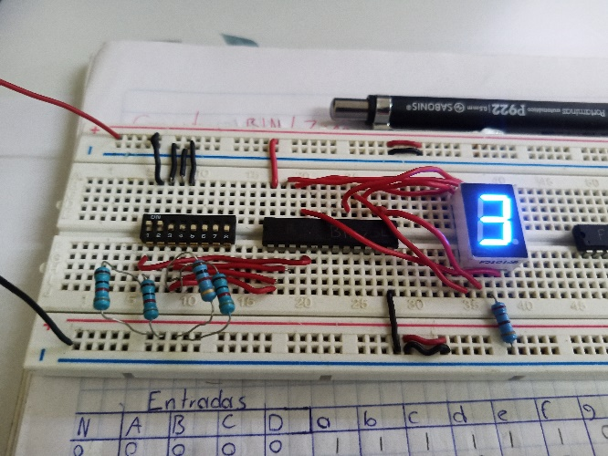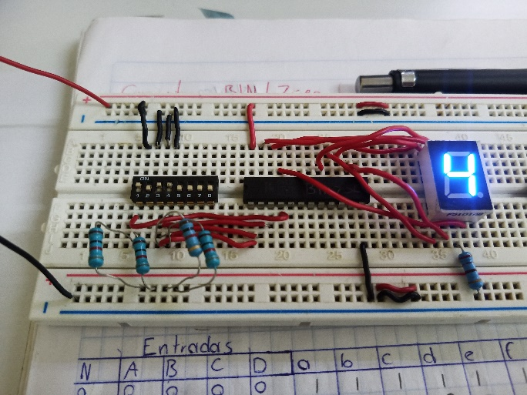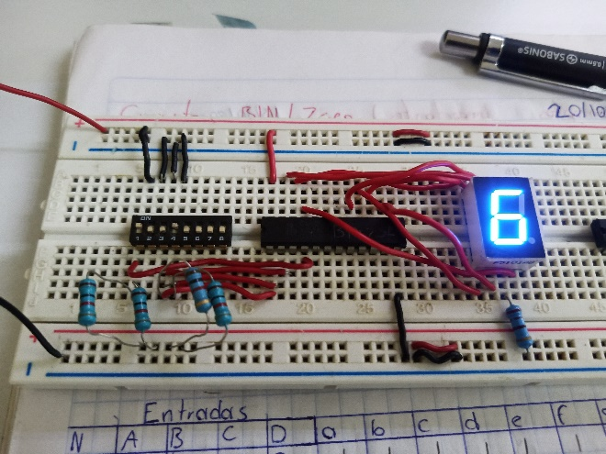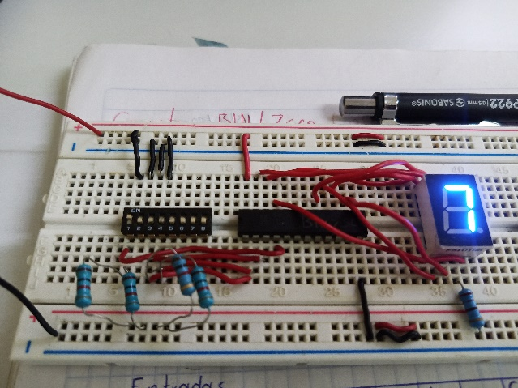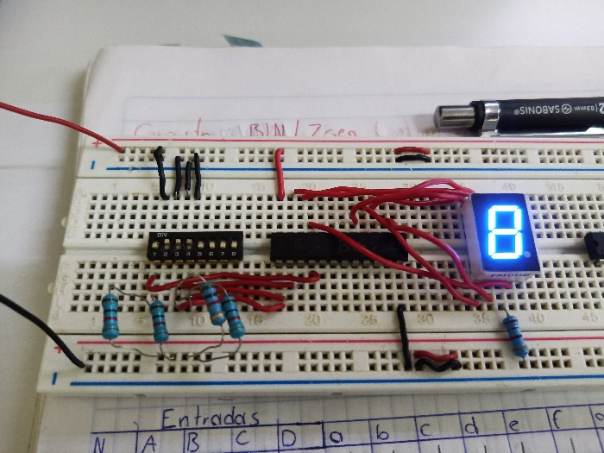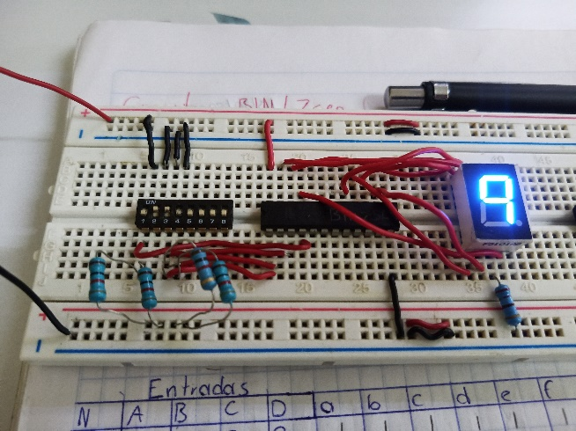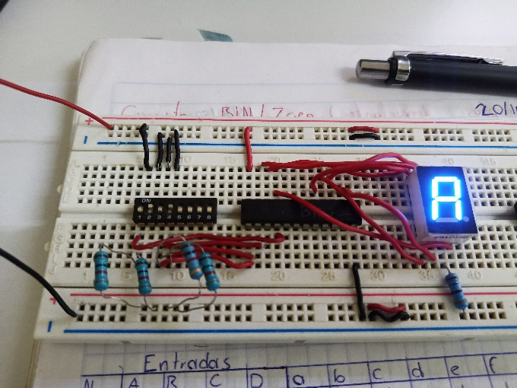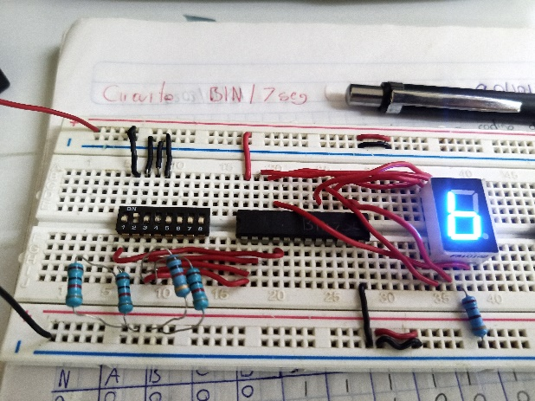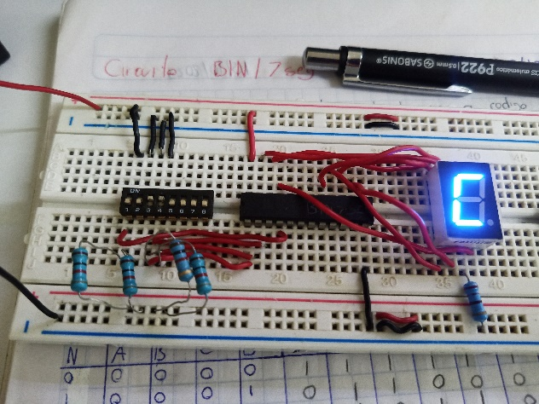
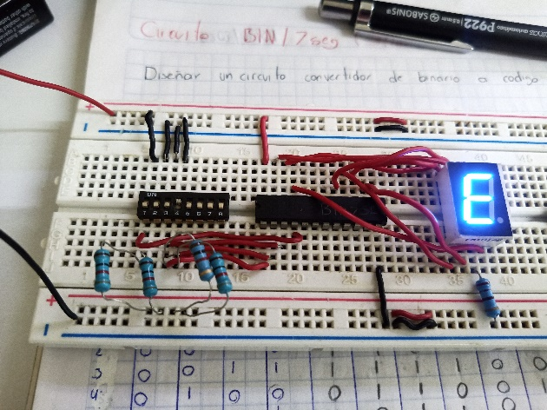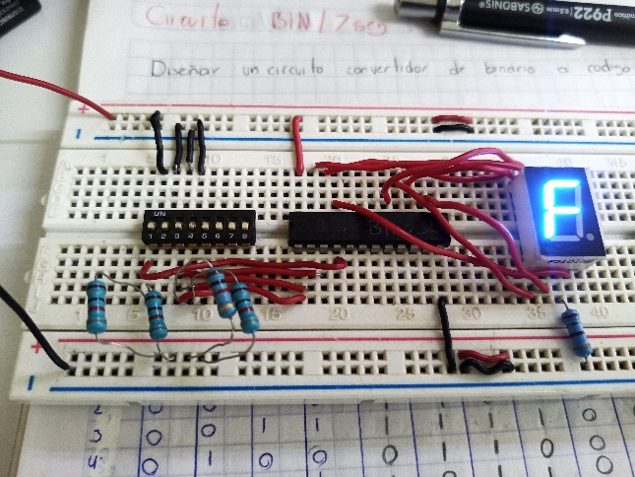

Simulaciones en VHDL Sim:
